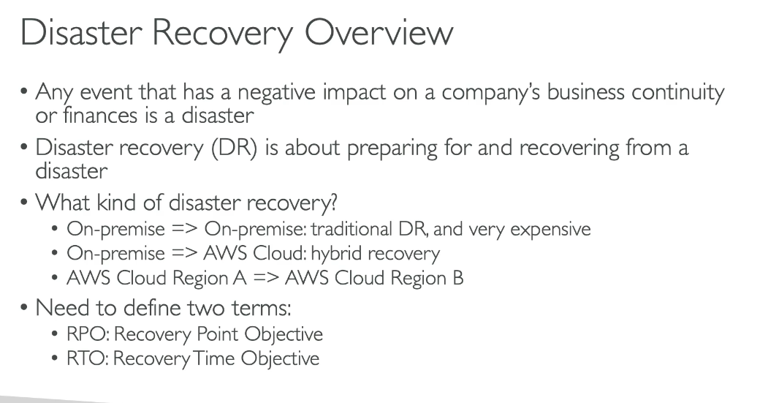

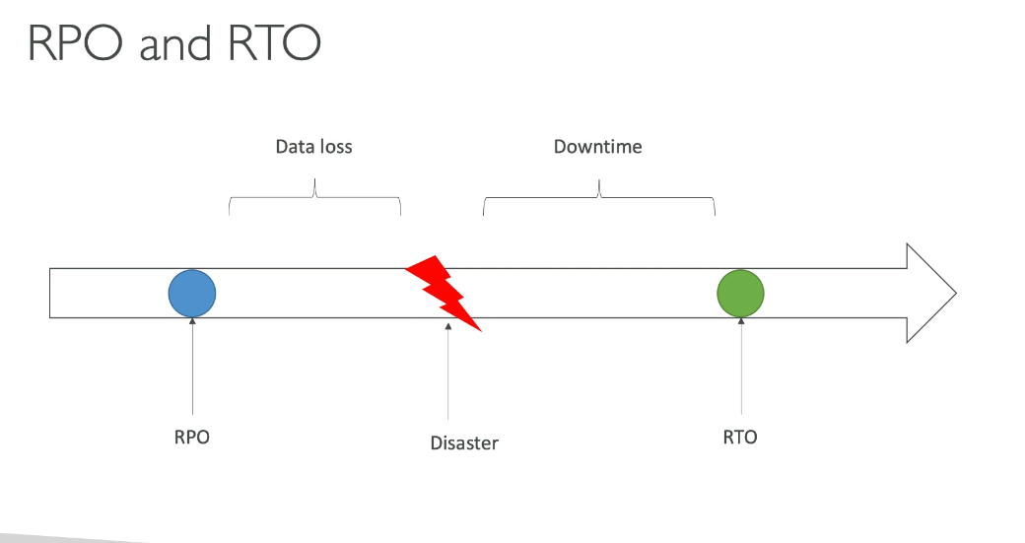

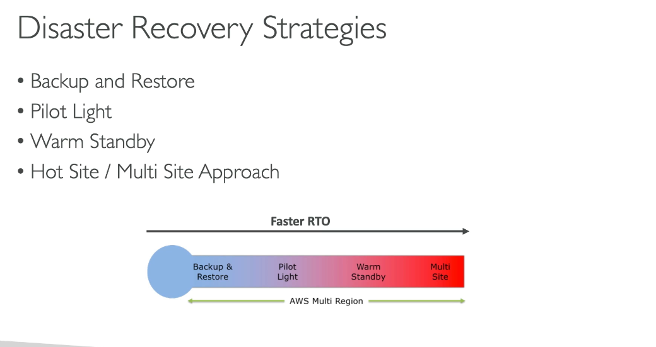

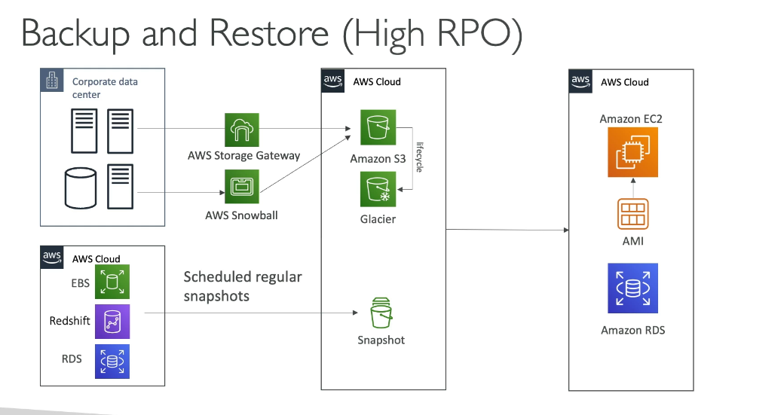

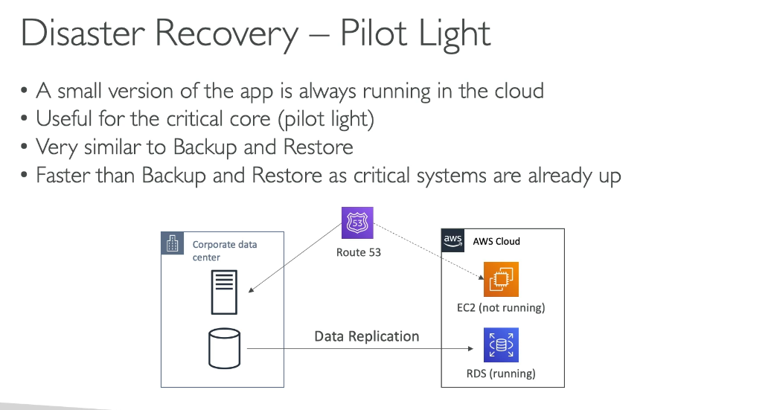

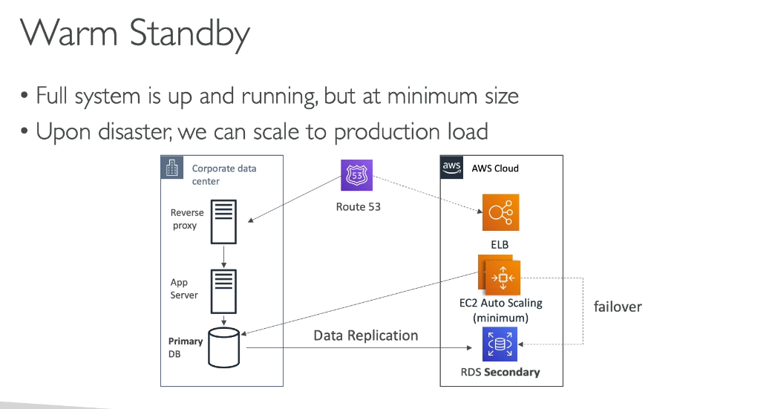

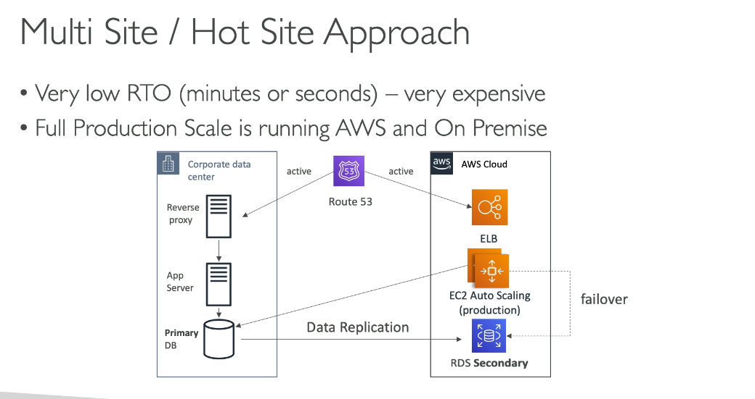

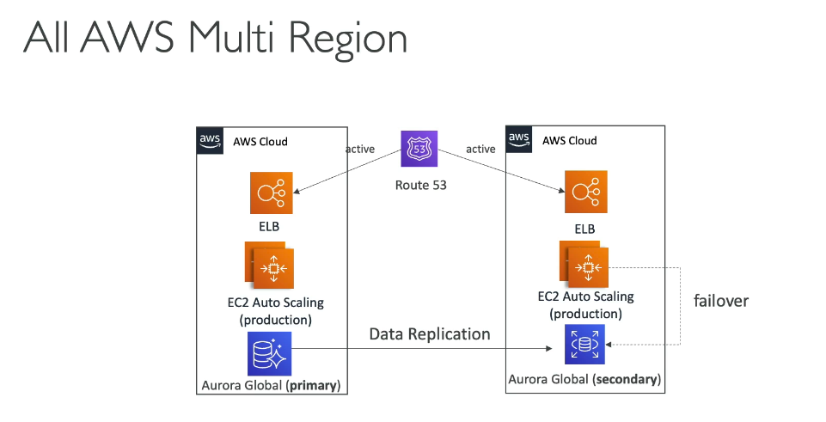

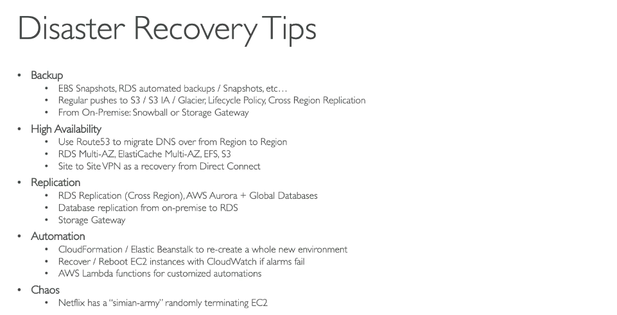

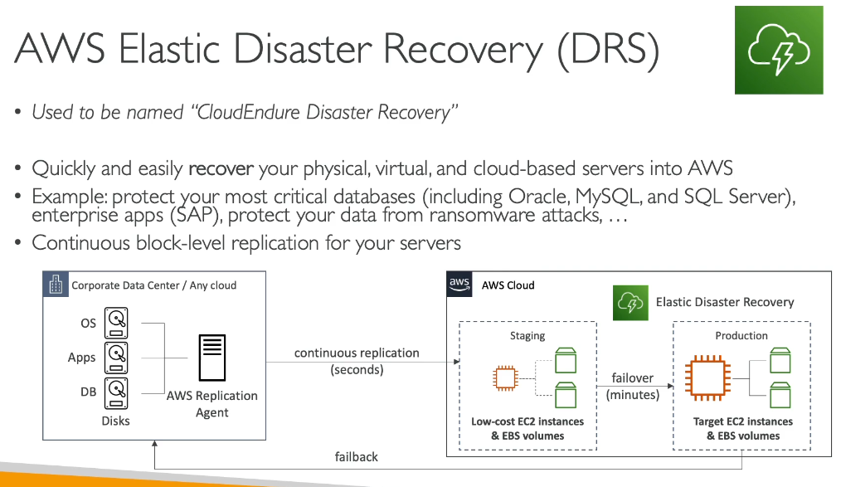

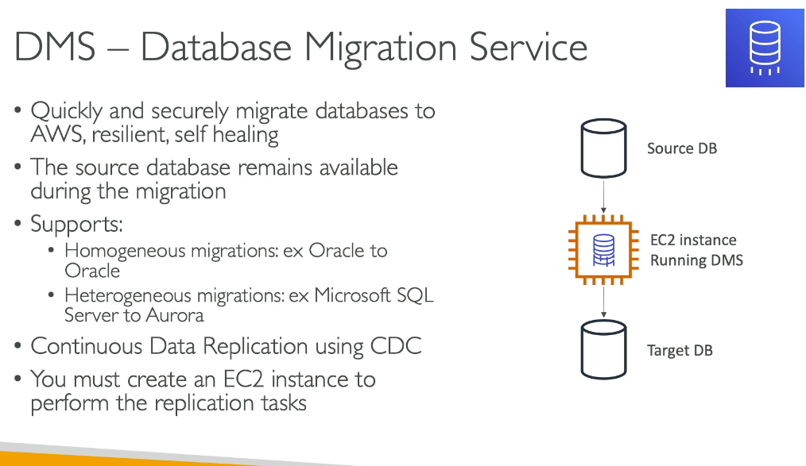

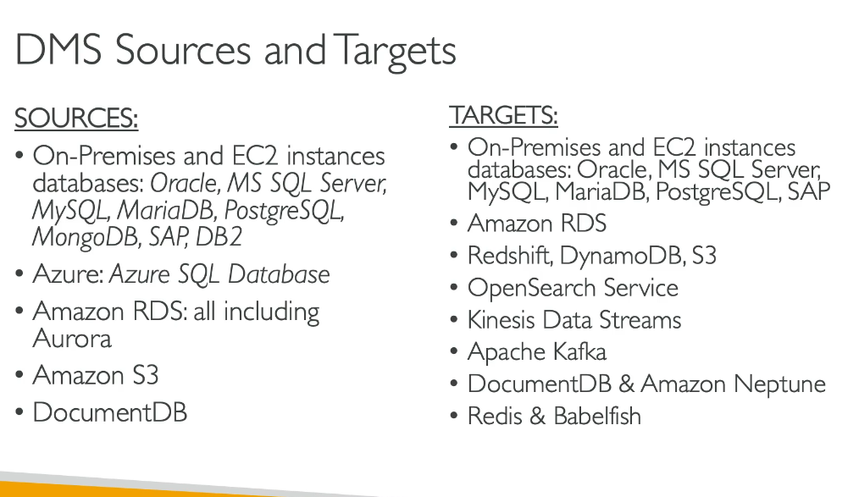

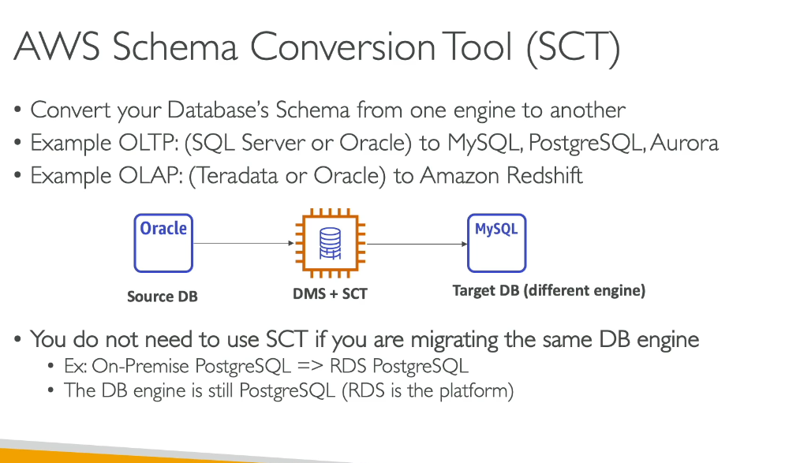

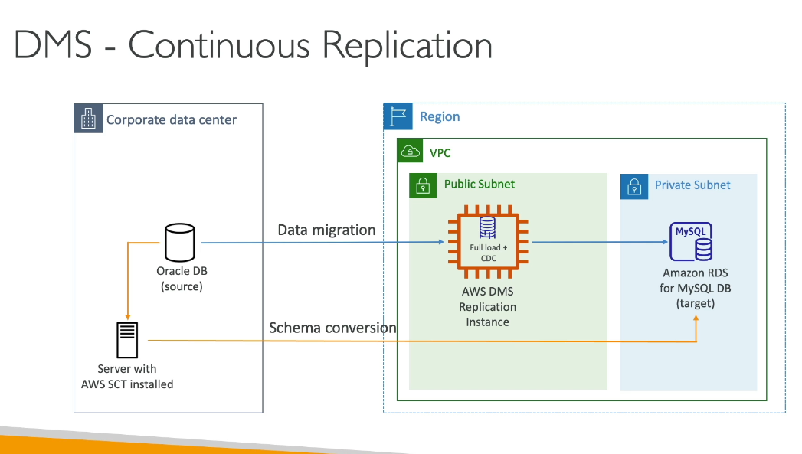

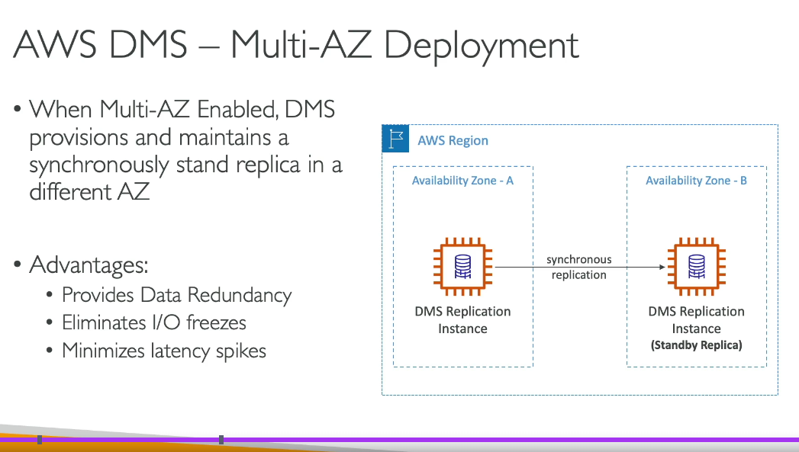

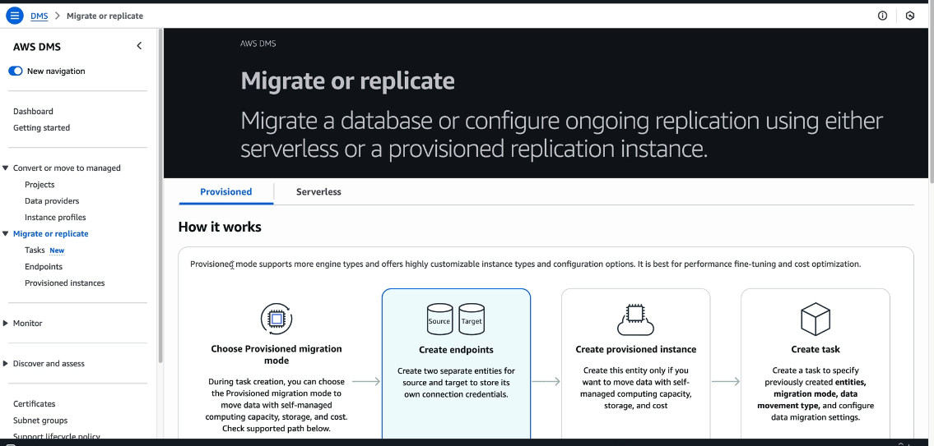Provisioned & Serverless

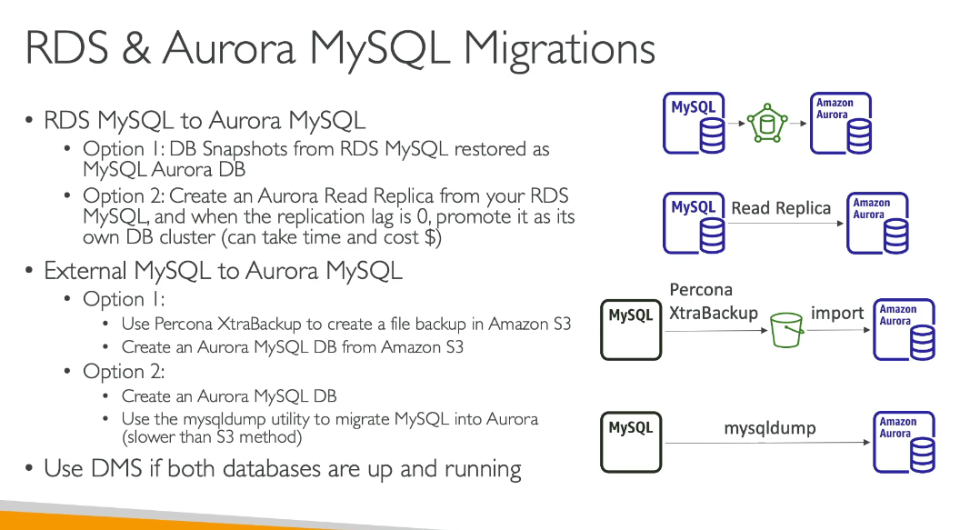

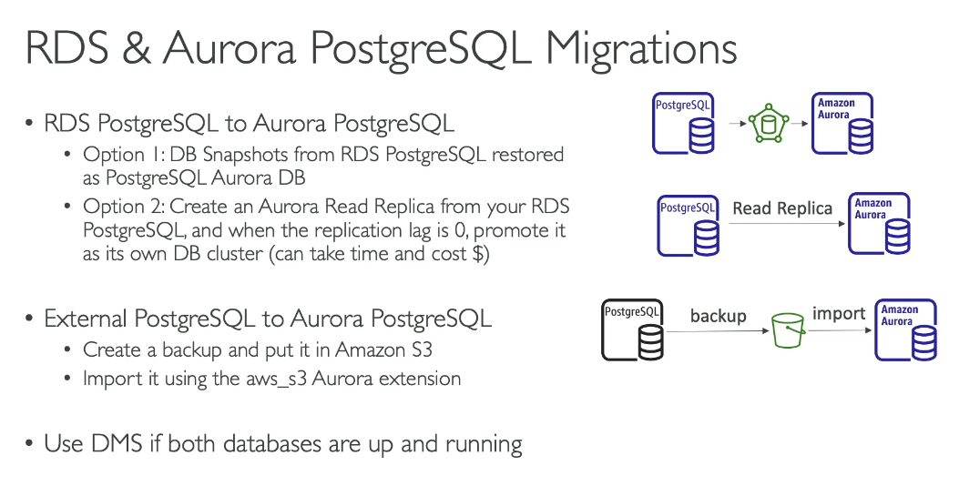

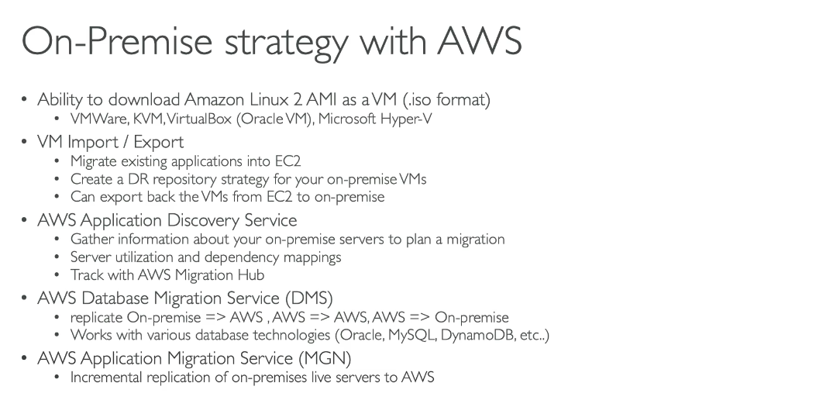

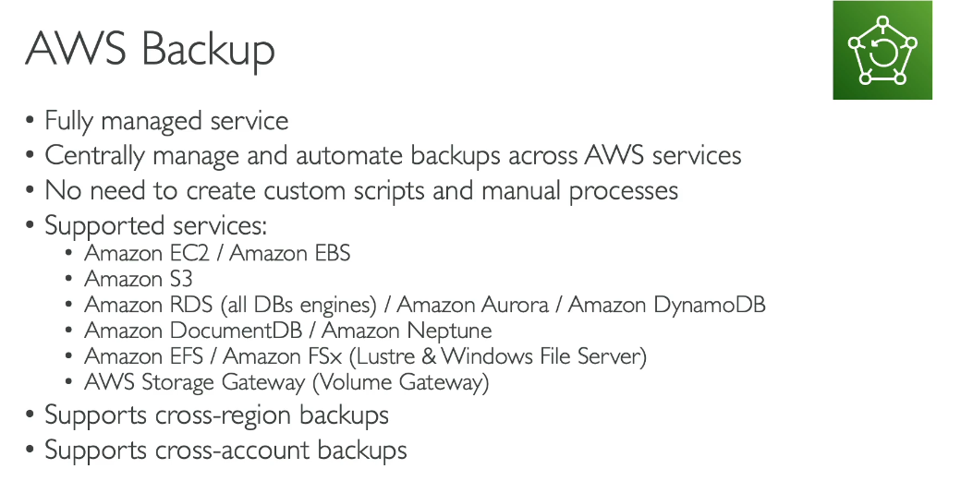

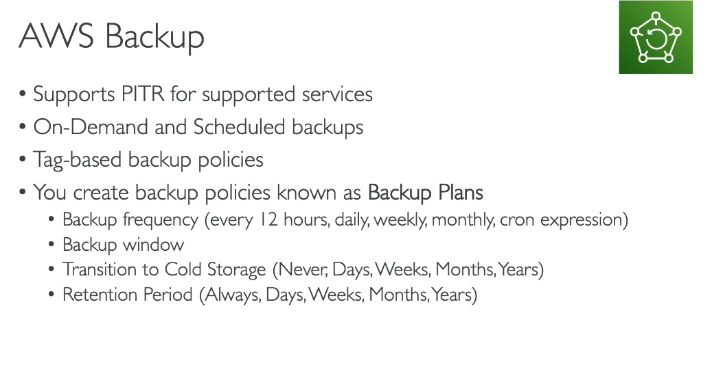

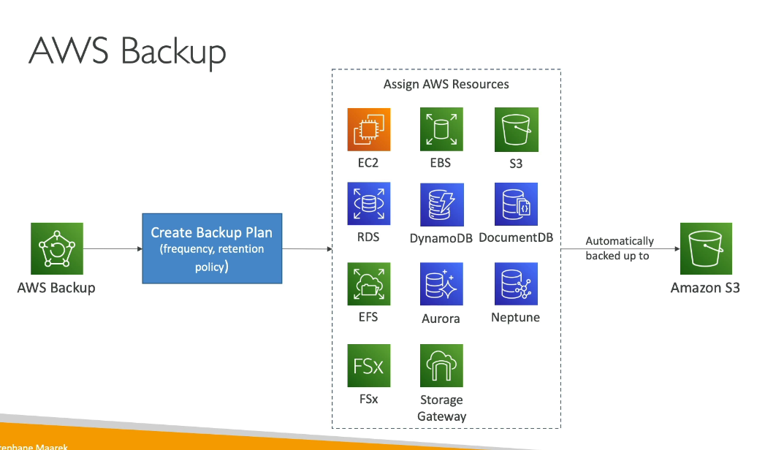

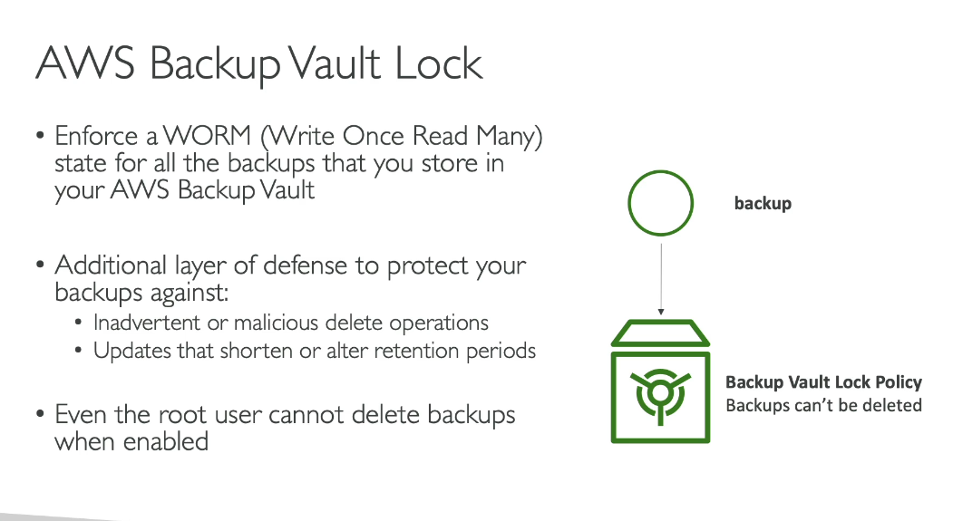

**Real-time Example:**

A healthcare company runs a patient management system on AWS using Amazon RDS for their database, Amazon EFS for medical records, and Amazon EC2 instances for their application servers. They use AWS Backup to create a centralized backup policy that automatically backs up all these resources daily at 2 AM, with weekly full backups retained for 7 years to meet HIPAA compliance requirements.

Where Backup Data is Stored:

AWS Backup stores your backup data in AWS Backup vaults, which are containers that organize and manage your backups. The backup data is stored in:

* Amazon S3 - AWS Backup uses S3 as the underlying storage infrastructure for most backup data
* AWS Regions - You choose which AWS Region(s) to store your backups, and can copy backups across different Regions for disaster recovery
* Logically air-gapped vaults - For enhanced security against ransomware, you can use isolated backup vaults with additional access controls

The service supports backing up data from 12+ AWS services including EC2, EBS, RDS, DynamoDB, EFS, FSx, and S3, all managed from a single centralized dashboard.

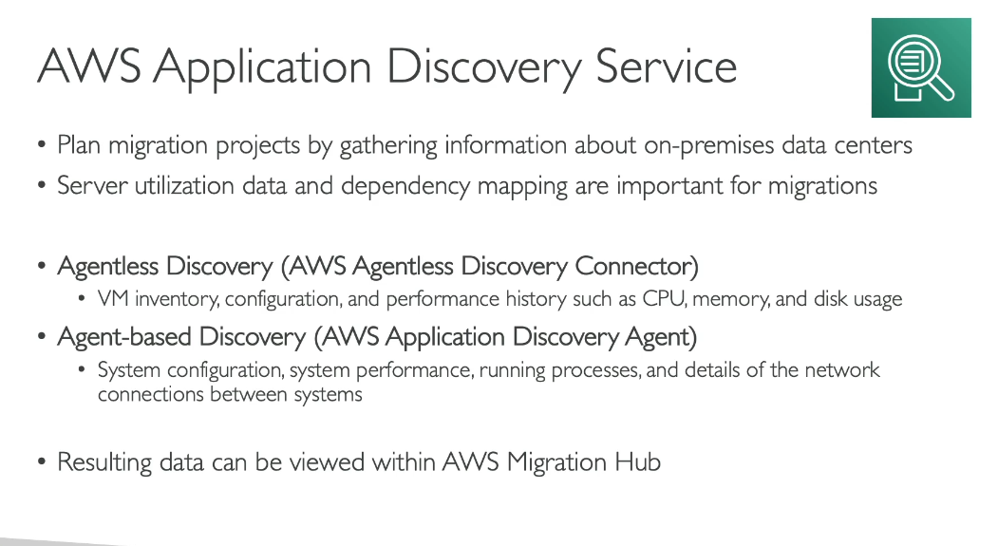

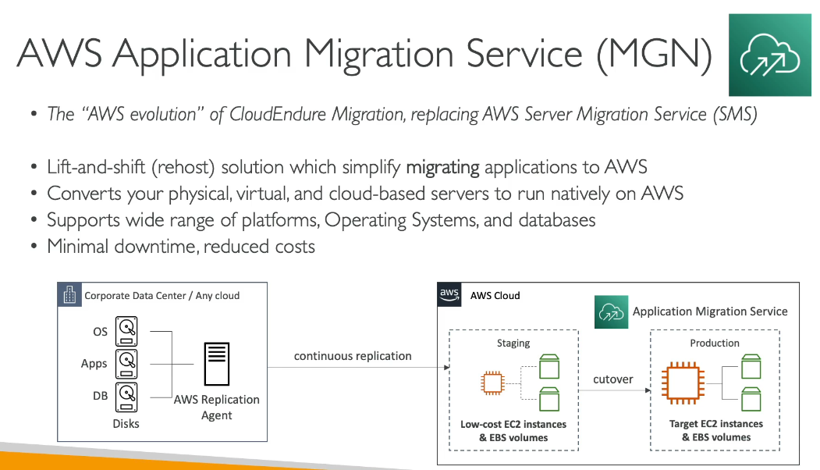

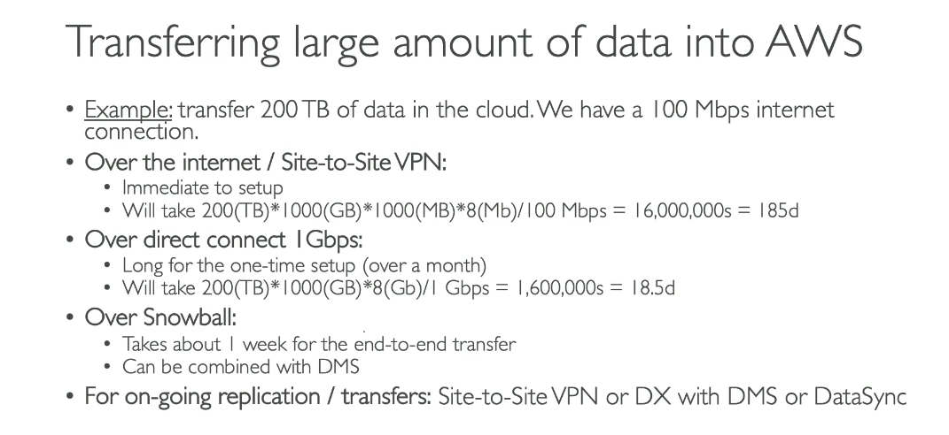

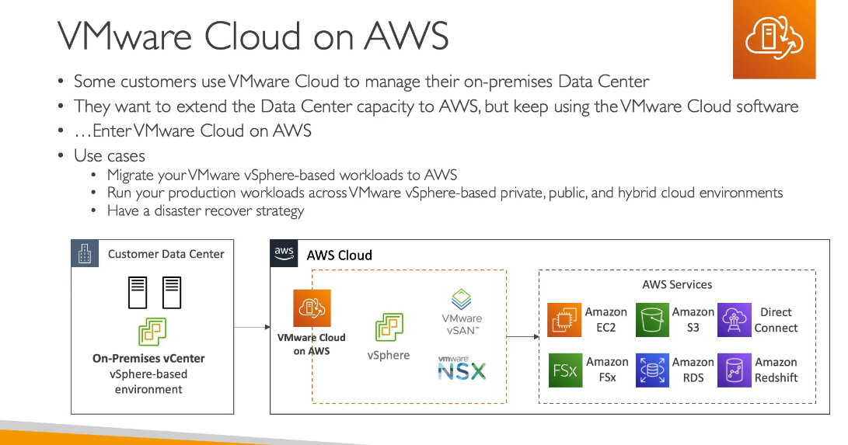

Quiz:

